**Name: Tayyaba Ambreen**

**Registration No.: 128300**

**Class: BESE-6B**

**Lab No. : 5**

**Lab Task**

1. Install R and R Studio.
2. Get your self familiarize with R language and its syntax. Go through all the challenges on <http://tryr.codeschool.com/>

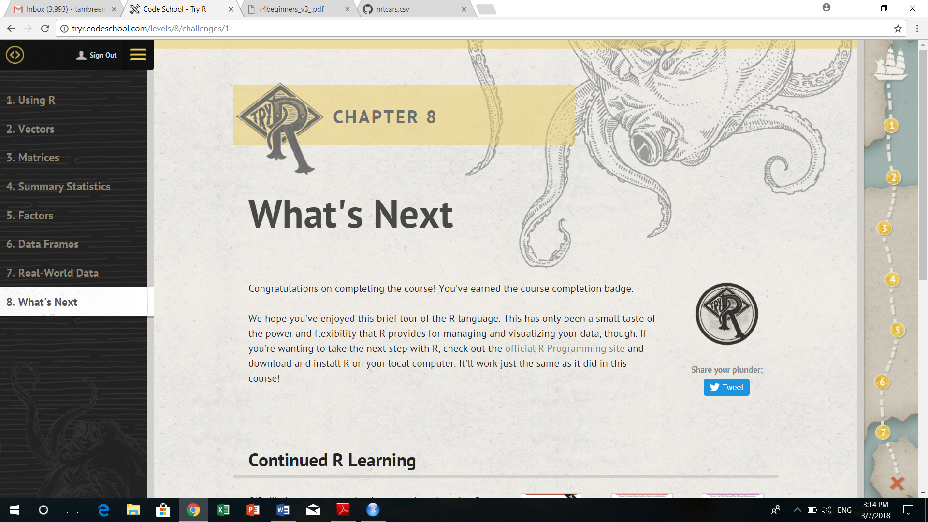

1. Complete reading and practice of Chapter Painless Data Visualization of R: a beginner’s guide (on LMS). (Pgs: 17 – 25)
2. Use the mtcars data set to plot different graphs in order to convince a buyer which is the best car to buy. Assume some kind of criteria that the car is interested in e.g. Young buyer with interest in speed, or an executive thinking of buying a luxury sedan etc.
3. Submit code and graphs developed in point 4.

**Graphs:**

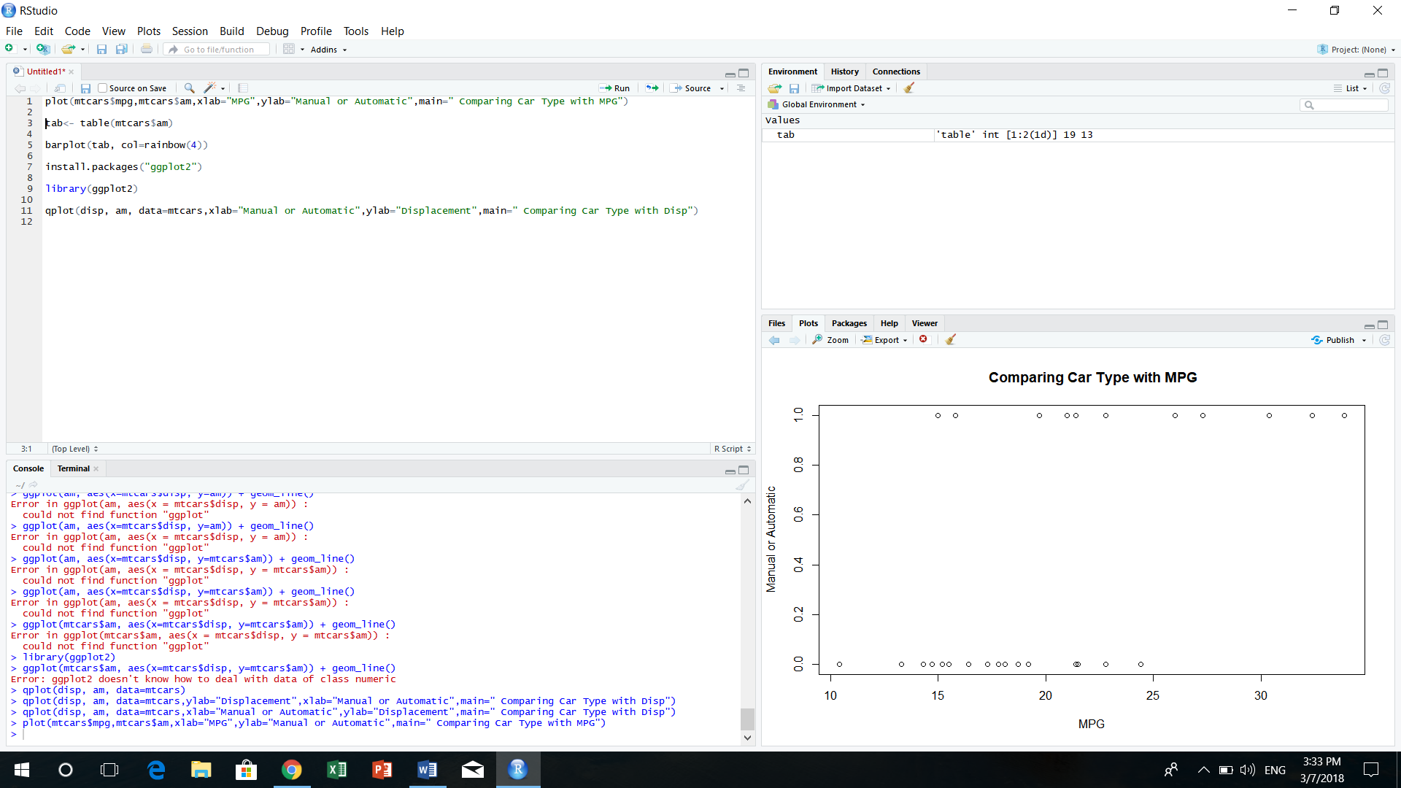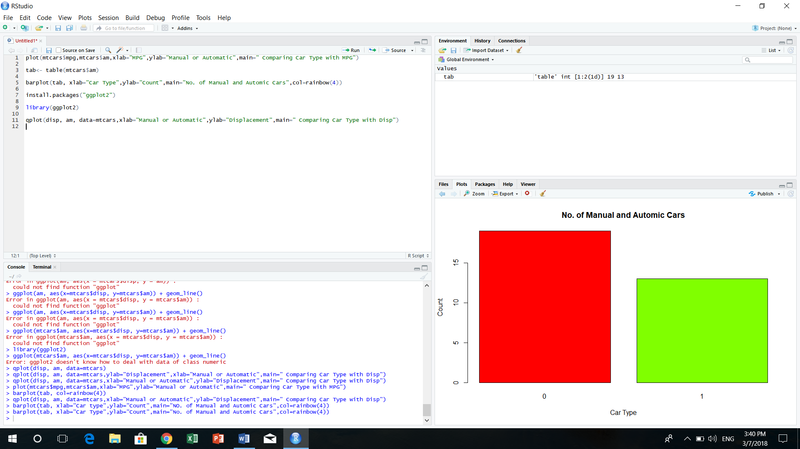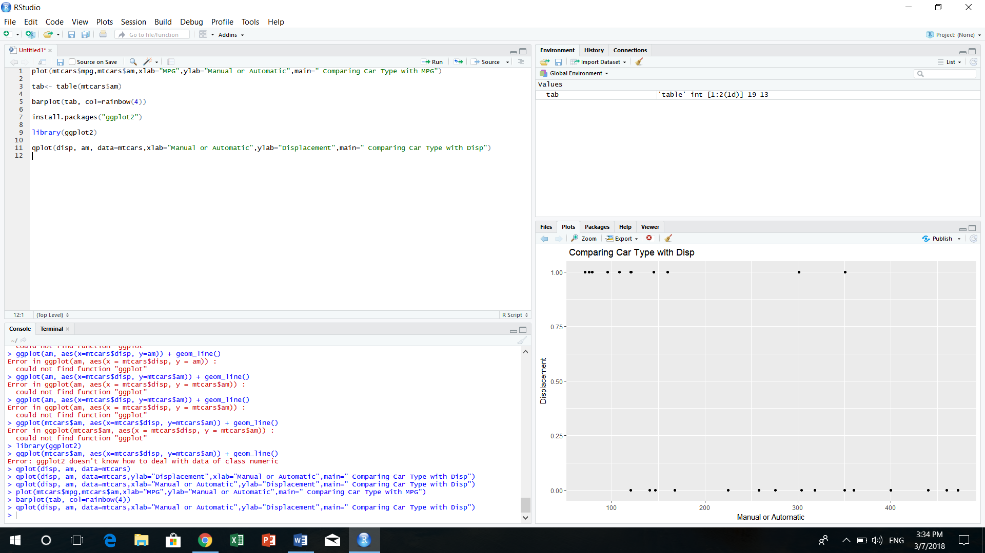

**Code:**

plot(mtcars$mpg,mtcars$am,xlab="MPG",ylab="Manual or Automatic",main=" Comparing Car Type with MPG")

tab<- table(mtcars$am)

barplot(tab, xlab="Car Type",ylab="Count",main="No. of Manual and Automic Cars",col=rainbow(4))

install.packages("ggplot2")

library(ggplot2)

qplot(disp, am, data=mtcars,xlab="Manual or Automatic",ylab="Displacement",main=" Comparing Car Type with Disp")